**Mini Project  
  
  
  
  
  
  
E-Commerce - Sales Data Analysis  
  
  
  
By  
Umasankari Palanivel**

**Project Overview**

This project focuses on the comprehensive analysis of E-Commerce Sales Data using Microsoft Excel and Power BI. The objective is to transform, model, and visualize the data to derive actionable business insights, identify trends, and measure performance against sales targets.

**Source Data Set**

The project is based on three key datasets:

Source - [Sales Data Analysis Raw Data](https://docs.google.com/spreadsheets/d/1Jw9nfW2N4Pwcr-iuOtW0Kg22D2JYnTxm/edit?usp=sharing&ouid=112832444573323250756&rtpof=true&sd=true)

* List of Orders.csv – Contains order-level details
* Order Details.csv – Includes product and quantity information
* Sales Target.csv – Provides target data for sales performance

**Tools & Technologies Used**

**• Microsoft Excel** – for data preparation and preliminary analysis  
**• Power BI** – for data transformation, modeling, and dashboard creation  
**• DAX (Data Analysis Expressions)** – for calculated columns and performance measures

**Phase 1 – Data Transformation & Data Modeling**

In this phase, data was imported, cleaned, and structured within Power BI using Power Query Editor. The following transformations and modeling steps were performed:

1. Imported all three CSV files into Power BI.  
2. Restricted the List of Orders table to the first 500 rows.  
3. Changed data types appropriately (Order Date → Date, Amount/Target → Fixed Decimal Number).  
4. Formatted Customer Names into Proper Case.  
5. Merged City and State columns to create a new ‘Location’ column.  
6. Added a custom ‘Profit Margin’ column (Profit ÷ Amount × 100).  
7. Added a conditional column ‘Profit Status’ (Profit, Loss, Break-Even).  
8. Merged ‘List of Orders’ and ‘Order Details’ into ‘Orders Data’ table using Order ID.  
9. Handled missing values and duplicates.  
10. Grouped and aggregated metrics such as average profit by category and total target by month.  
11. Established relationships:  
 - List of Orders ↔ Order Details via Order ID  
 - Order Details ↔ Sales Target via Category **1. Import Data:**Import & Transform the following Tables   
“List of Orders.csv”  
“Order Details.csv” and “Sales target.csv” into Power Query Editor are Done

**2. Data Transformation:**1. **Restrict the "List of Orders" table to only the first 500 rows.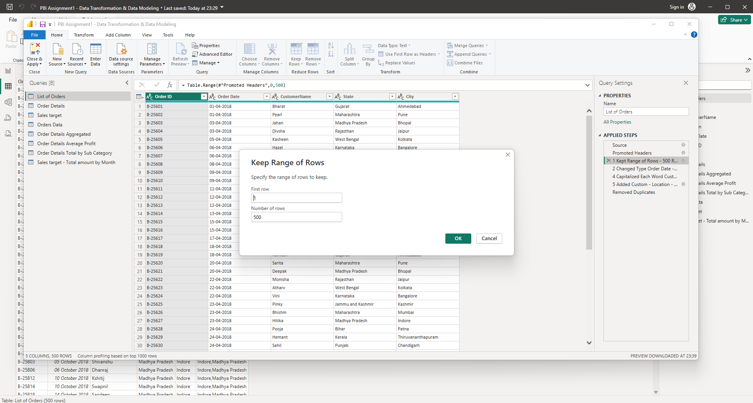 2. Ensure the “Order Date” column in the “List of Orders” table is set to data type 'Date'.**

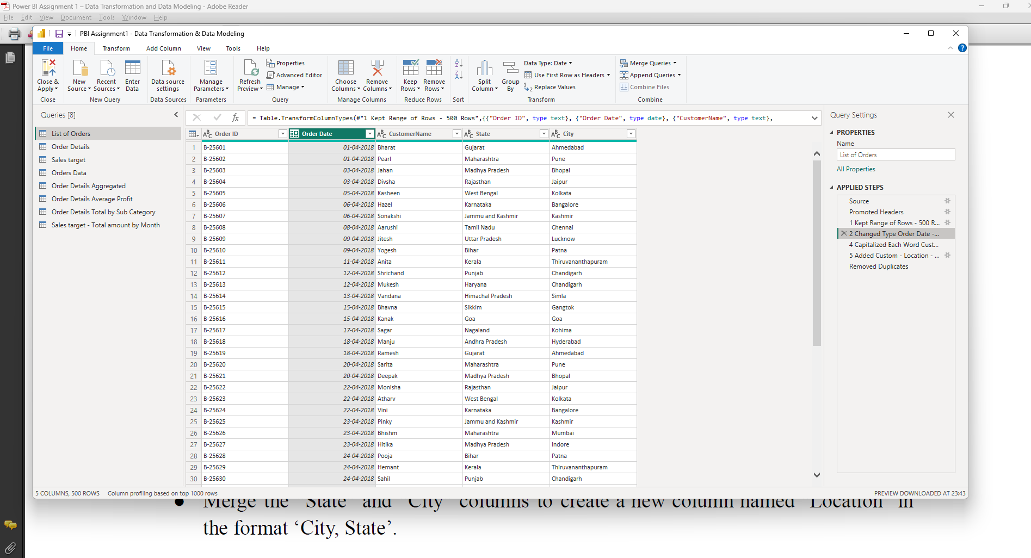

**3.Change the data type of “Amount” and “Target” columns to ‘Fixed Decimal Number’   
  
Order Details – Amount & Profit Column – Change Data Type – Fixed Decimal Number  
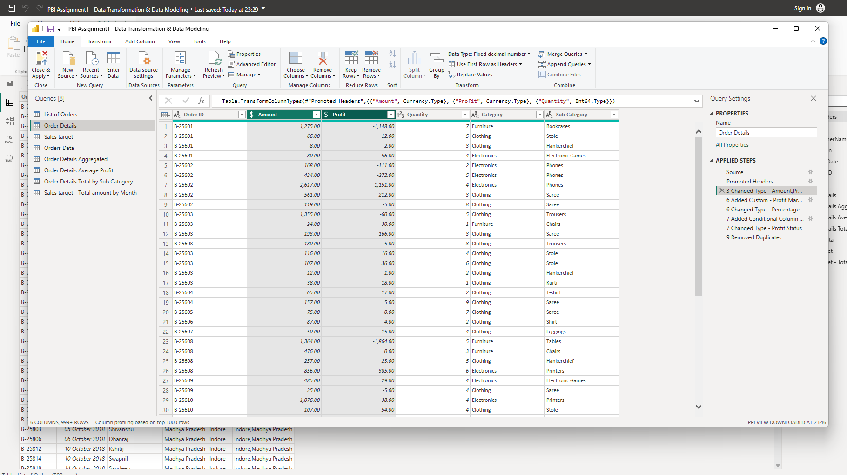  
  
Sales Target – Target Amount Column – Data Type Changed to Fixed Decimal Number  
  
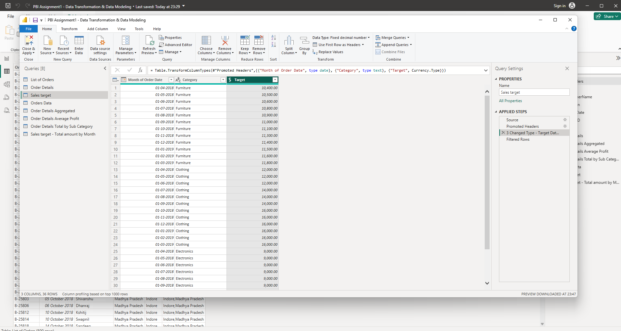  
  
  
4. Format the "Customer Name" column into proper case, ensuring consistent capitalization for each word.   
  
capitalization for each word – Customer Name  
  
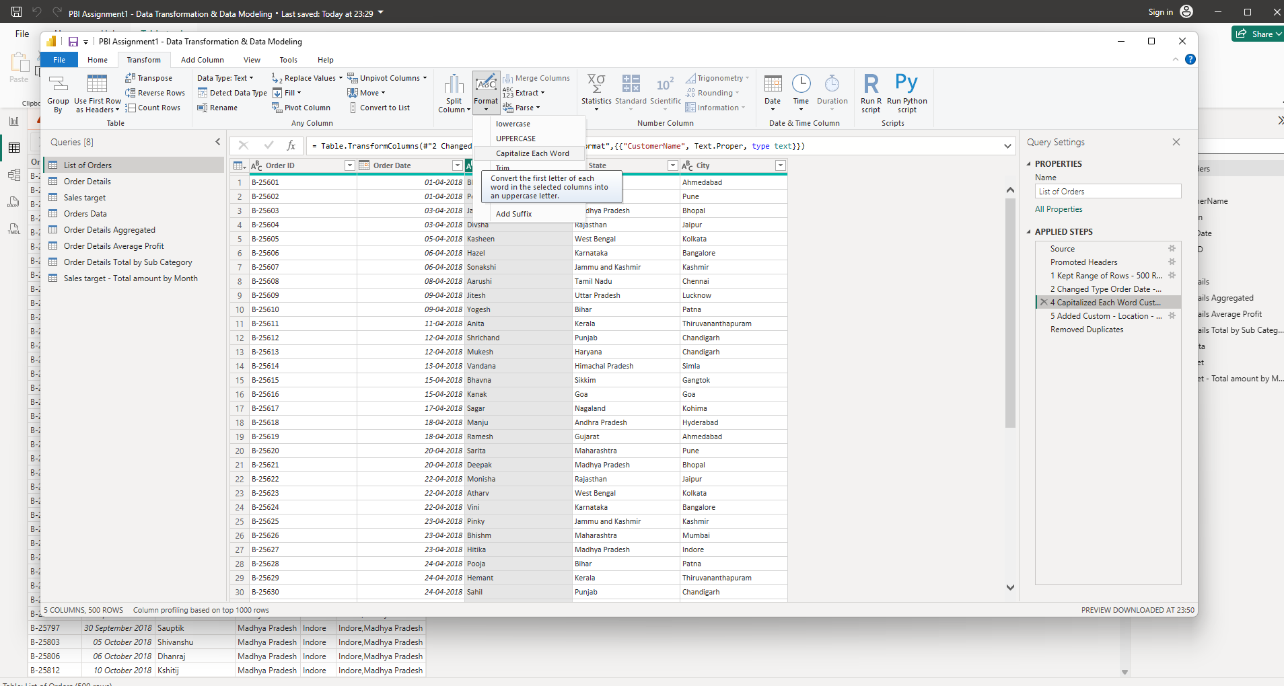  
  
5. Merge the "State" and "City" columns to create a new column named "Location" in the format ‘City, State’.   
  
Location – Merge State & City Column  
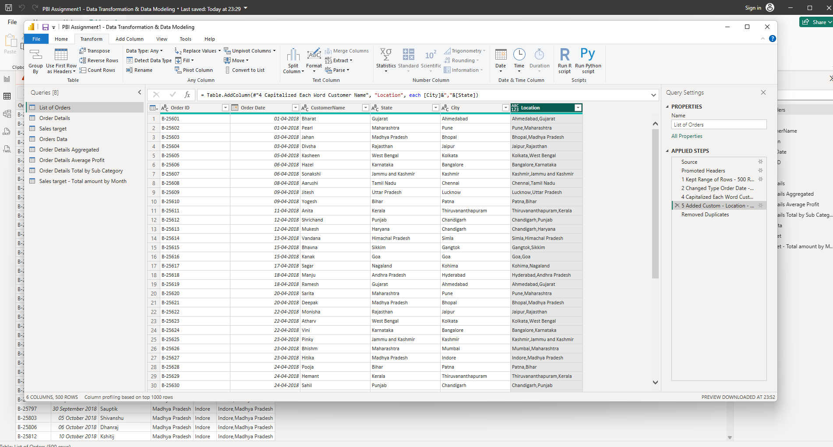**

**6.Create a new custom column named "Profit Margin" as the percentage of "Profit" divided by "Amount".   
  
Profit Margin Column  
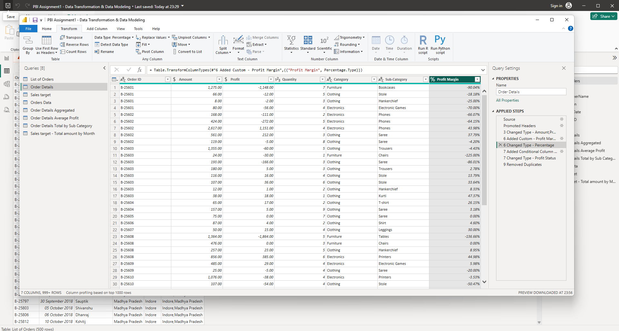  
  
7.Add a new conditional column named "Profit Status" based on the values in the "Profit" column. The conditions are as follows: if the profit is less than 0, the label should be "Loss"; if the profit equals 0, the label should be "Break-Even"; and if the profit is greater than 0, the label should be "Profit".   
  
Profit Status Column  
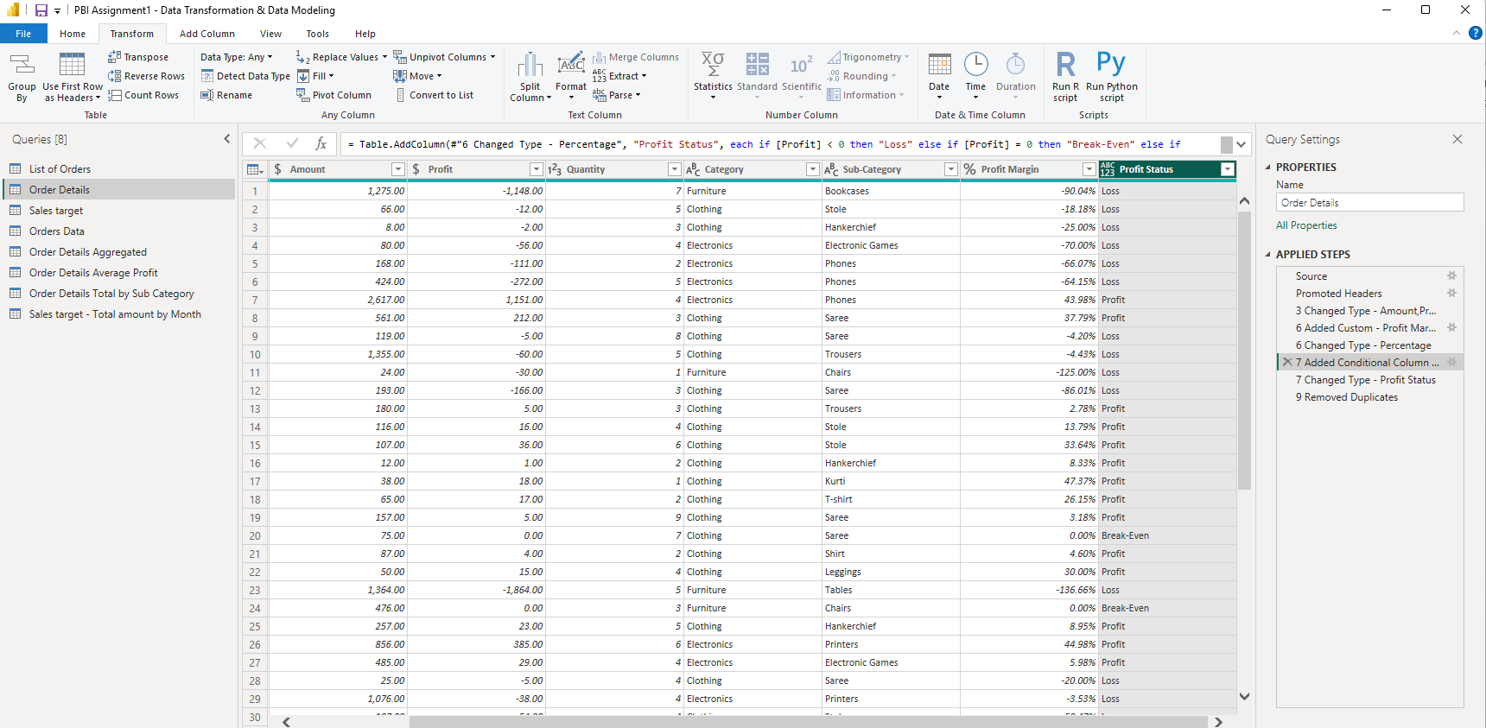  
  
Merging Data (Joins):**

**●** Merge the "List of Orders" and "Order Details" tables into a new single table named "Orders Data" based on the "Order ID" relationship.  
  
**Orders Data Table**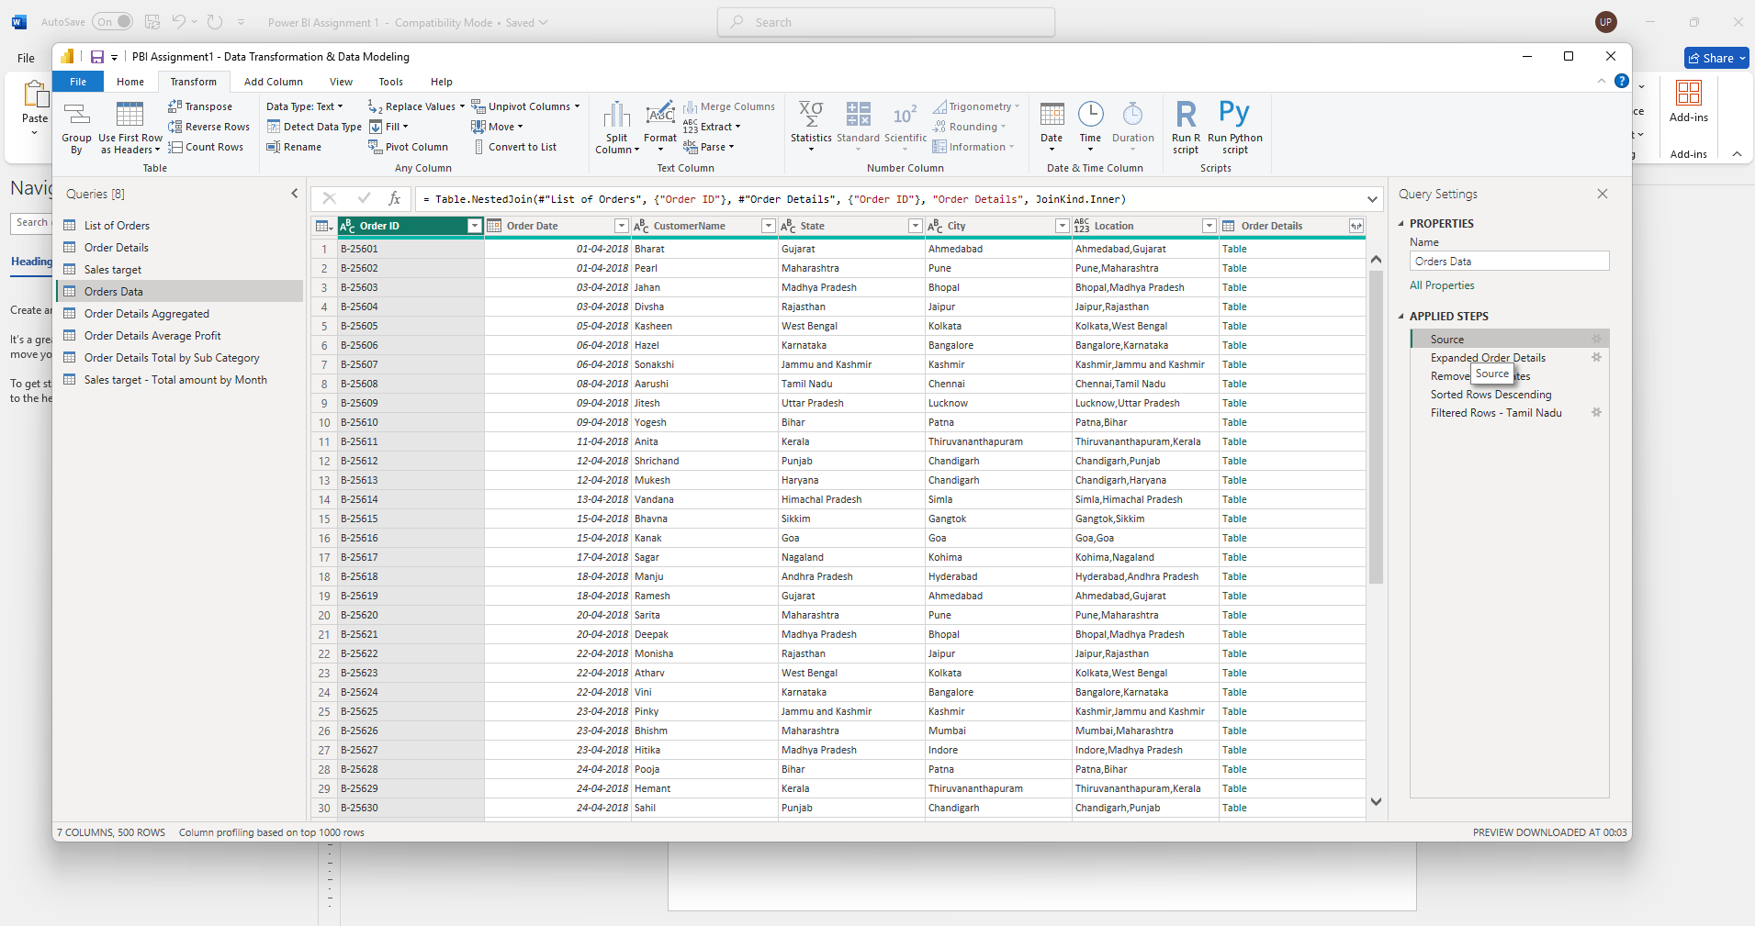

**Handling Missing Data & Duplicate Data:**

**●** Identify missing values in the data and determine a strategy to address them.

● Check for duplicate rows and define a strategy to handle duplicates.

**Sorting and Filtering Data:**

**● In the ‘Orders Data’ table, utilize sorting and filtering techniques on columns like Order Date, State or Category to analyze data based on specific criteria:**

**◆ Sort the orders by Order Date in descending order to analyze recent trends.**   
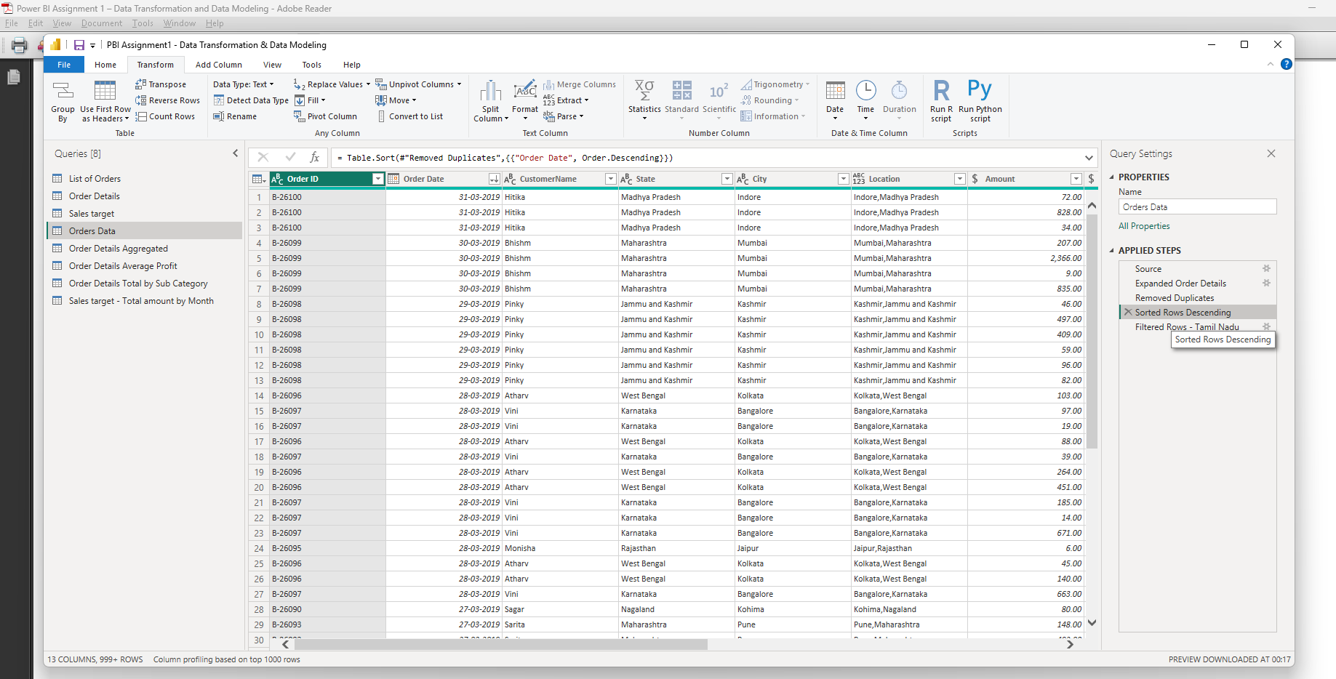  
  
◆ **Filter the orders to focus only on a specific state (e.g., Tamil Nadu) for regional analysis.**   
  
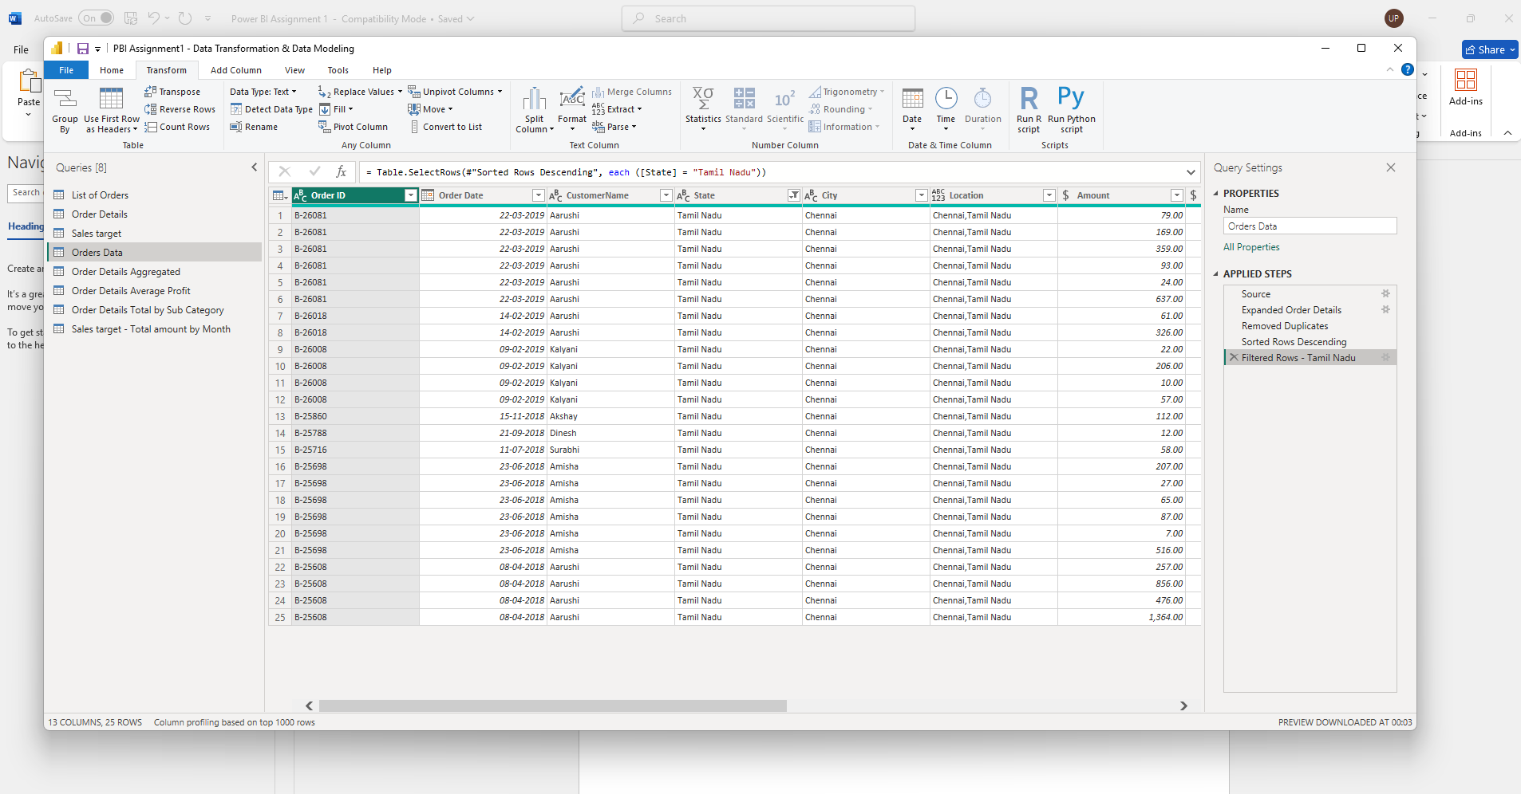

**Grouping and Aggregating Data:**

● Duplicate the “Order Details” table and calculate the count of each Order ID, average profit by Category or total amount by Sub-Category.   
 **“Order Details” table and calculate the count of each Order ID - Order Details Aggregated**  
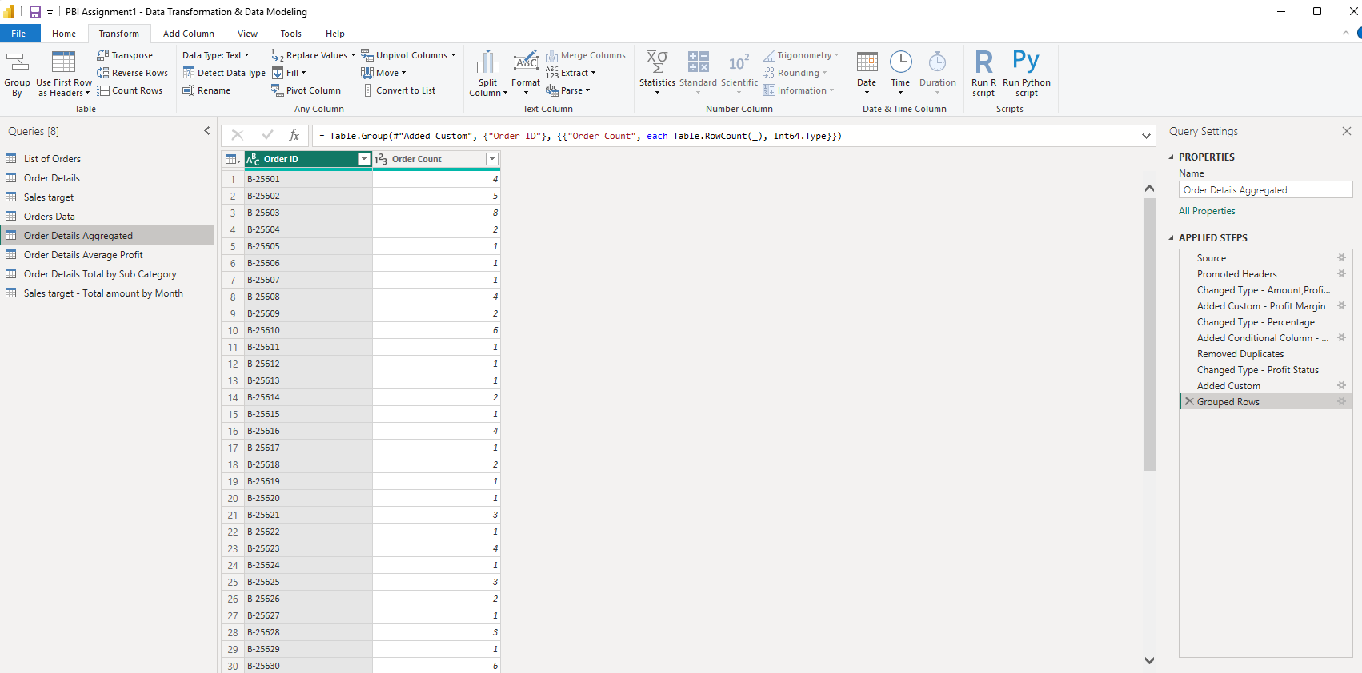 **Average Profit by Category**  
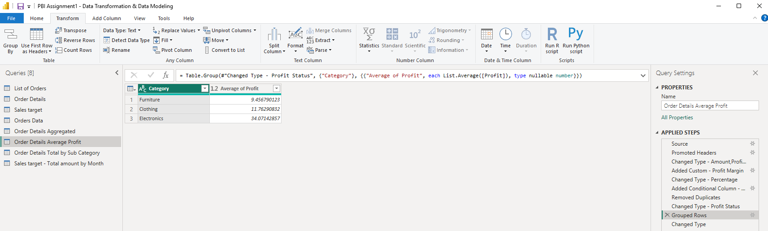

● Duplicate the “Sales Target” table and aggregate the total target amount by Month of Order Date.

**Total Target amount by “Month” of Order Date**

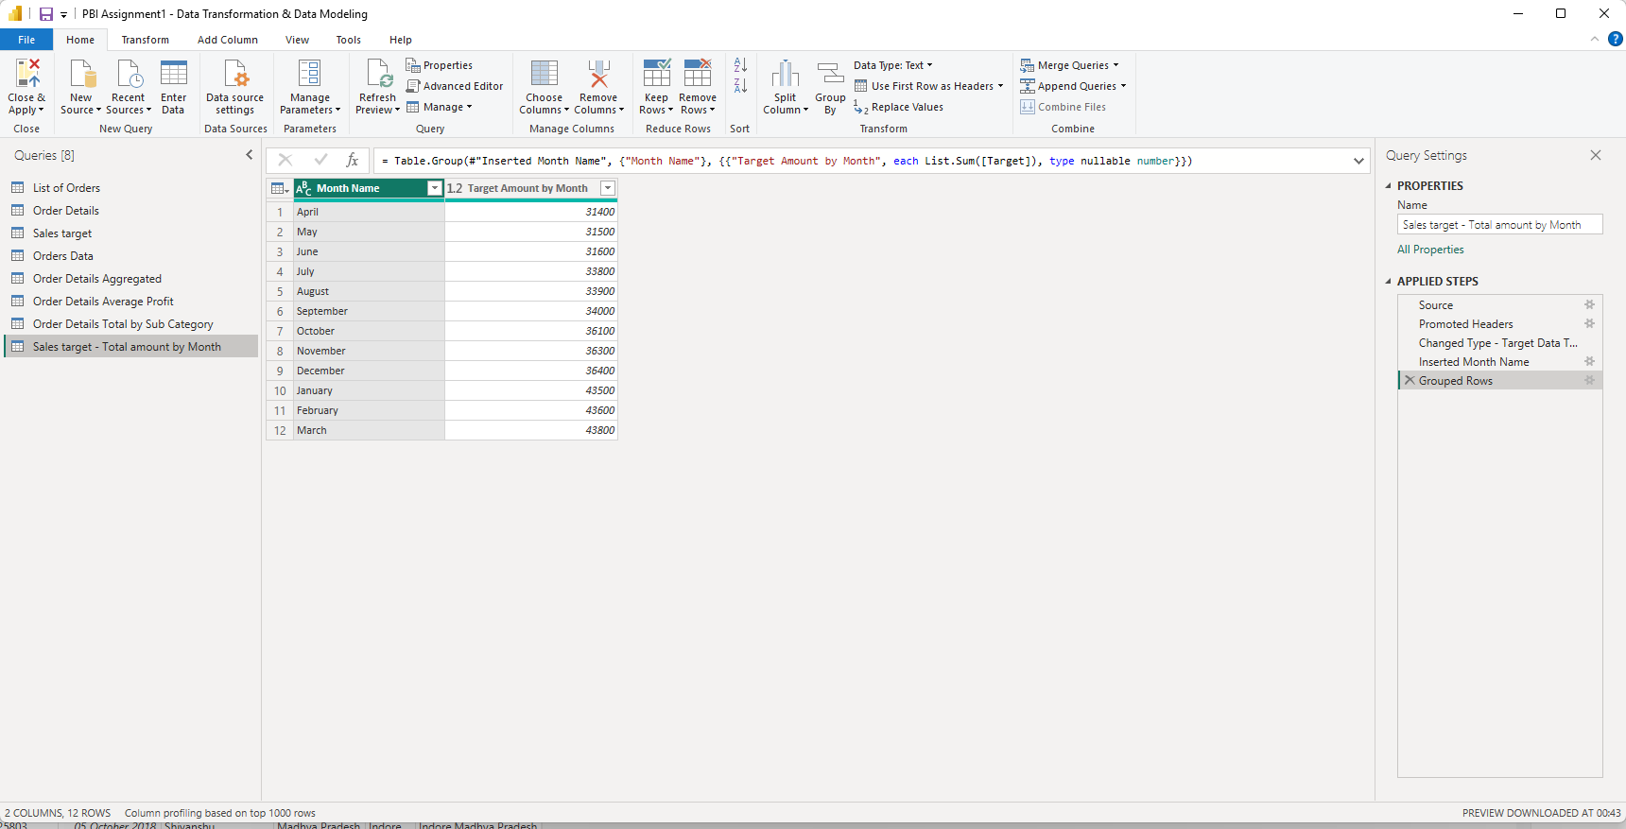  
**3. Data Modeling:**

● Establish a relationship between the “List of Orders” and “Order Details” tables using the ‘Order ID’ column.

● Build a relationship between the “Order Details” and “Sales Target” tables based on the ‘Category’ column. Click "Manage relationships" and ensure this relationship is active.   
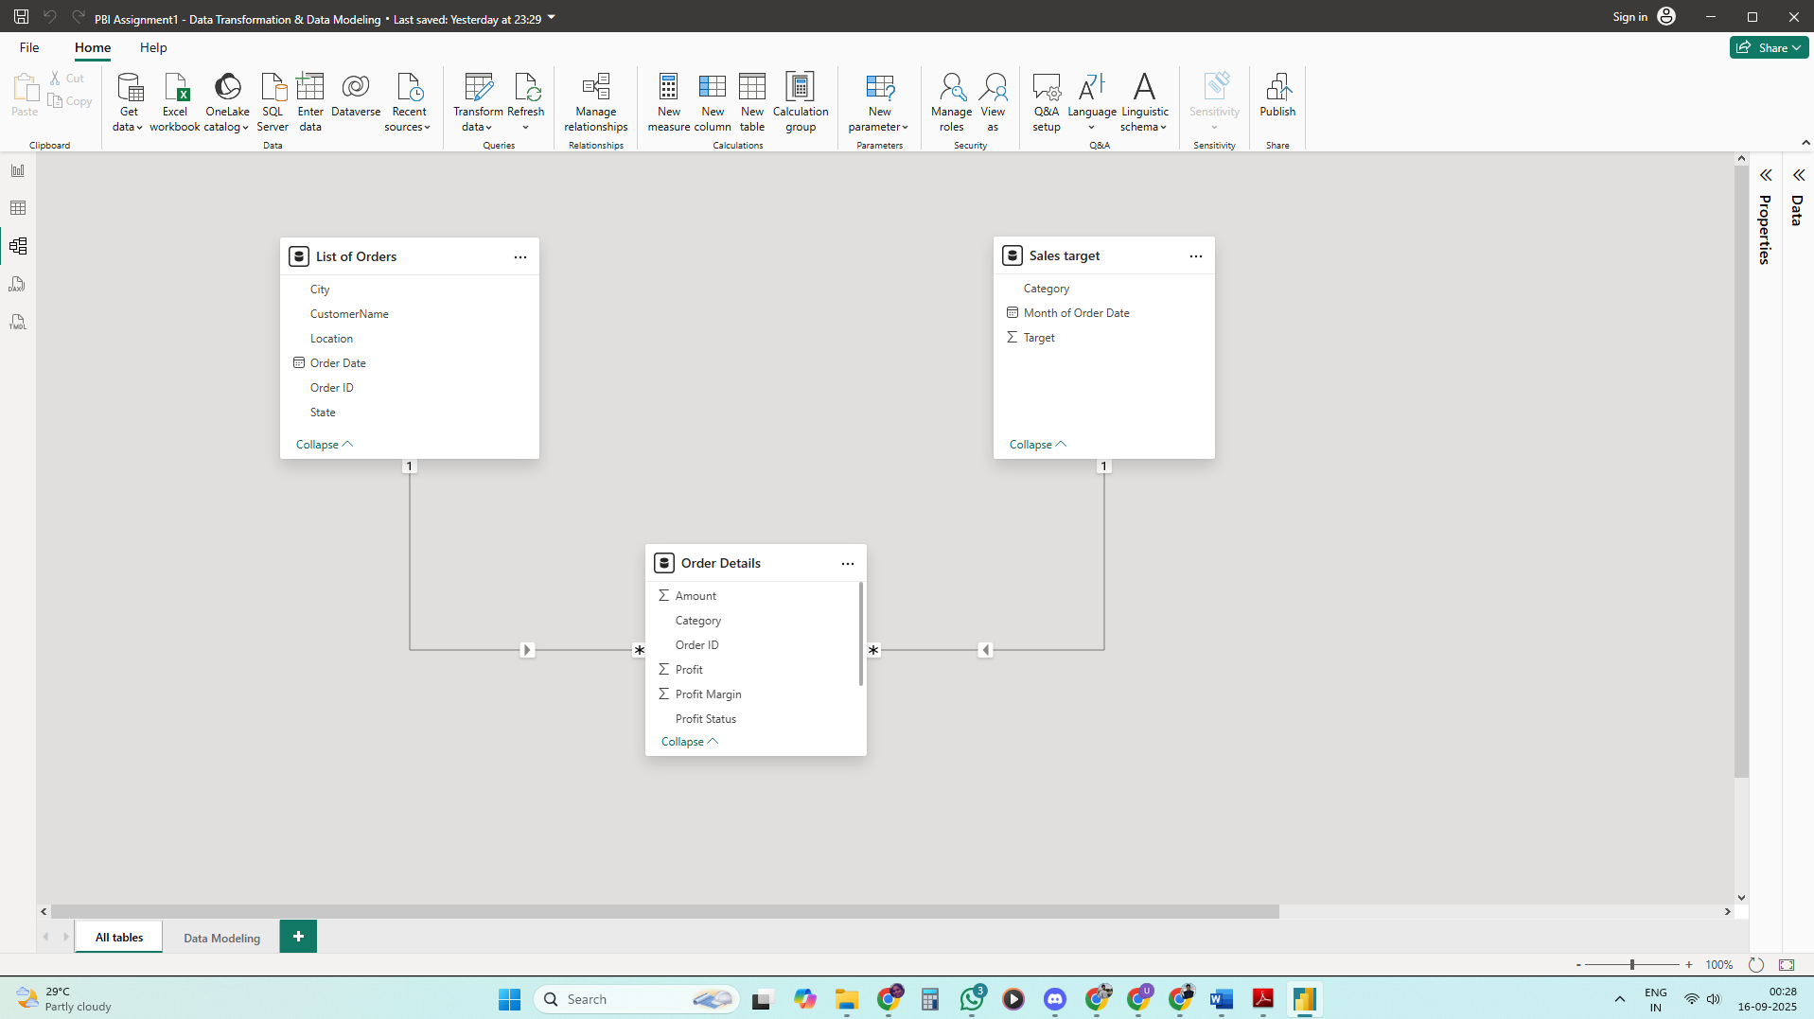

**Phase 2 – DAX & Data Visualization**

This phase involved the creation of calculated columns, DAX measures, and interactive Power BI dashboards to visualize key business metrics and trends.

**Calculated Columns**

• Category Type = Category & “-” & Sub-Category  
• Revenue per Order = Amount × Quantity  
• Sales Category = IF(Amount > AVERAGE(Amount), 'Above Average', 'Below Average')

**Calculated Measure**

• Order Count = DISTINCTCOUNT (Order ID)  
• Average Profit in Delhi = CALCULATE(AVERAGE(Profit), City = 'Delhi')  
• Year-to-Date (YTD) Sales = TOTALYTD(SUM(Amount), Order Date)

**Data Visualizations**

Multiple interactive visuals were created to analyze performance and uncover trends:

1. Clustered Column Chart – Sales Target Achievement by Category  
   2. Donut Chart – Max Profit Margin by Sub-Category  
   3. Line Chart – Monthly Sales Trend  
   4. Scatter Chart – Profit vs Quantity by Sub-Category  
   5. Cards – Total Sales vs Sales Target  
   6. Multi-Row Card – Minimum Target per Segment  
   7. Matrix Table – Sales vs Target by Category and Month  
   8. Map Visual – Geographic Sales Analysis by City  
   9. Treemap – Sales Distribution by Sub-Category  
   10. Funnel Chart – Order Count Analysis by State

**Calculated Columns:**

● **Create a Calculated Column for 'Category Type':** Add a calculated column in the Order Details table that combines the 'Category' and 'Sub-Category' columns into a single 'Category Type' column.   
  
**Formula:** Category Type = 'Order Details'[Category]&"-"&'Order Details'[Sub-Category]  
  
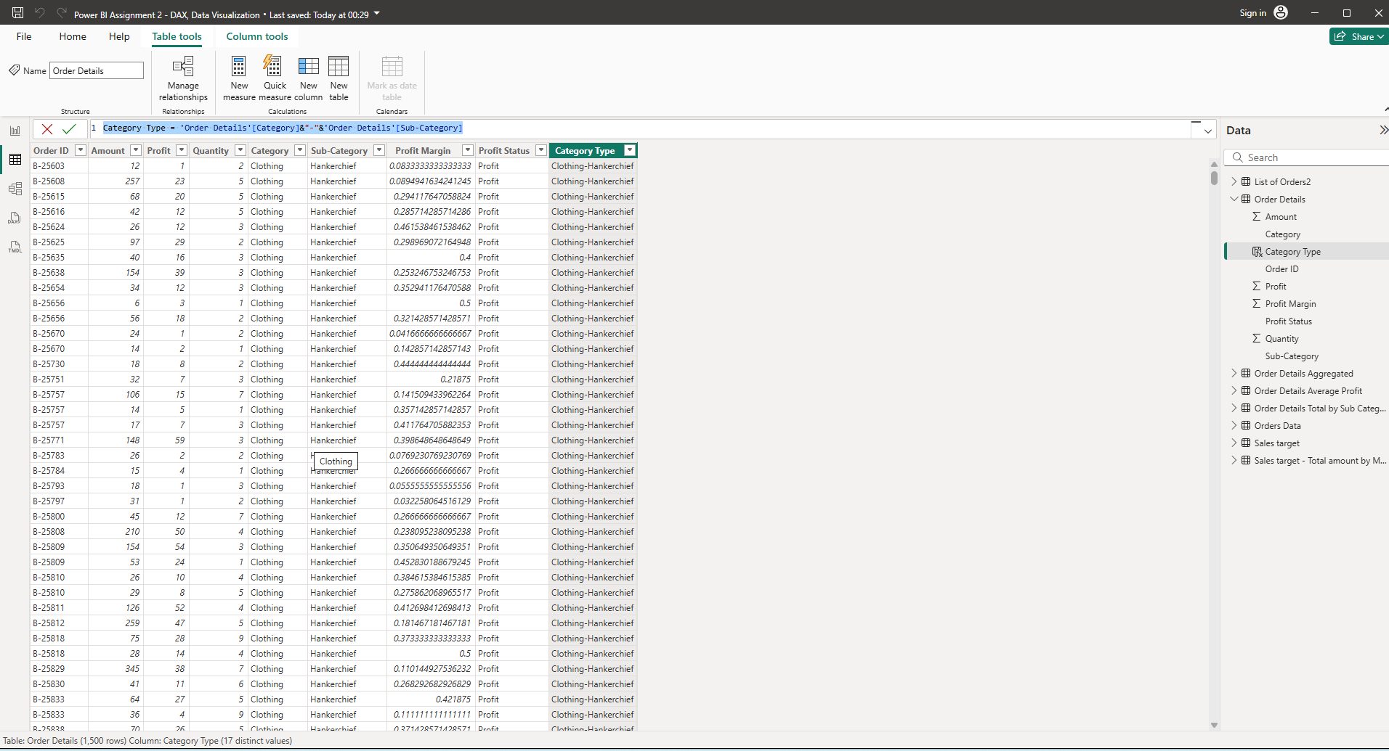

* **Calculate Revenue per Order in Order Details Table:** Create a calculated column in the Order Details table to compute the revenue (Amount * Quantity) per order.   
    
  **Formula:** Revenue = 'Order Details'[Amount]*'Order Details'[Quantity]

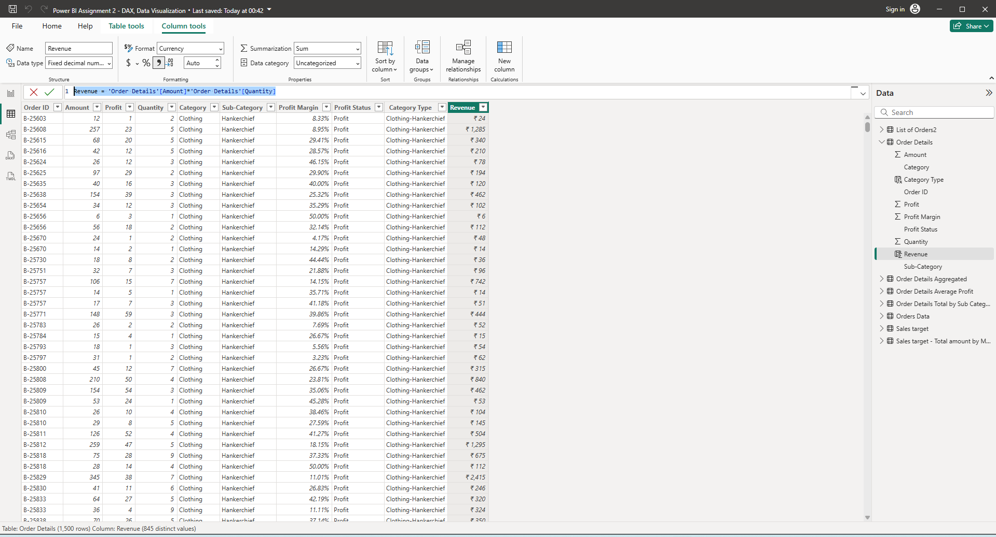

* **Create a Calculated Column to Categorize Sales:** Add a calculated column named ‘Sales Category’ in the Order Details table that categorizes each order as 'Above Average' or 'Below Average' based on the Amount value.

**Formula: Sales** Category = IF ('Order Details'[Amount]>AVERAGE ('Order Details'[Amount]),"Above Average”, “Below Average")

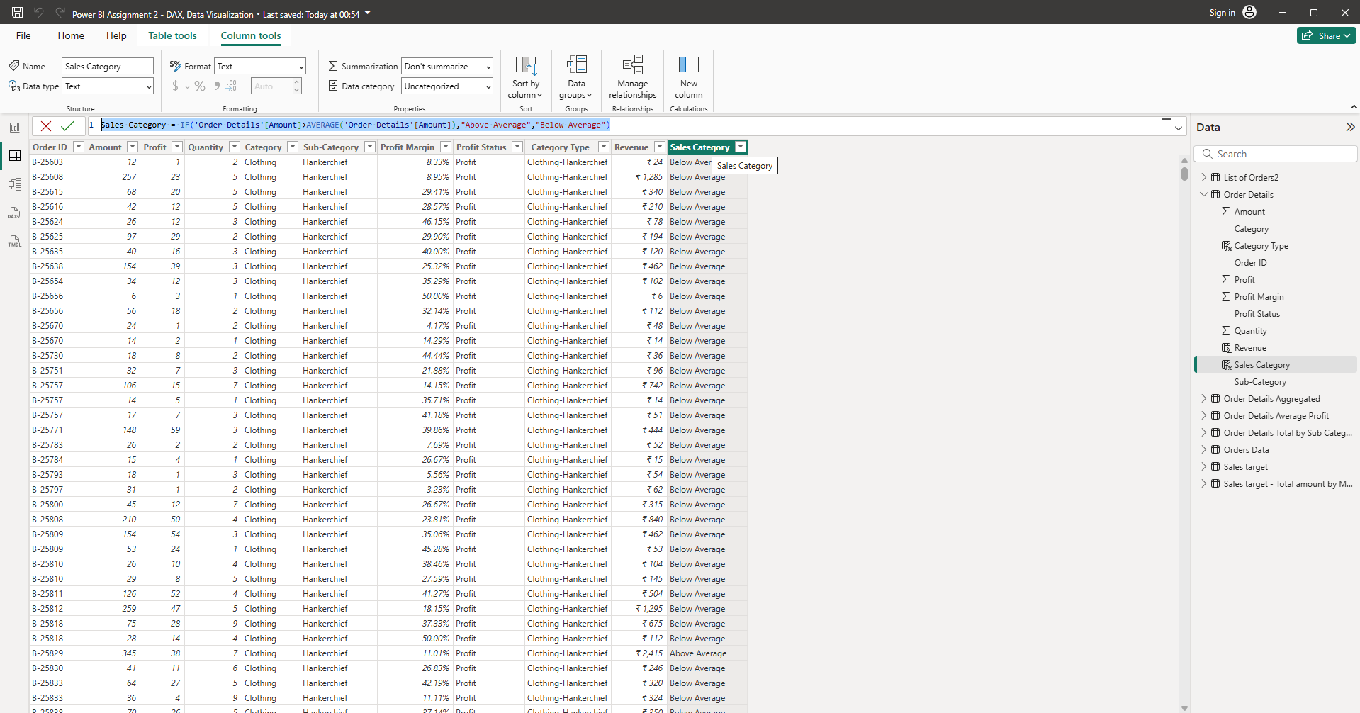

**Calculated Measures:**

● **Calculate Order Count**: Define a measure to count the total number of orders in the Order Details table.   
  
**Formula:** Order Count = DISTINCTCOUNT ('Order Details'[Order ID])

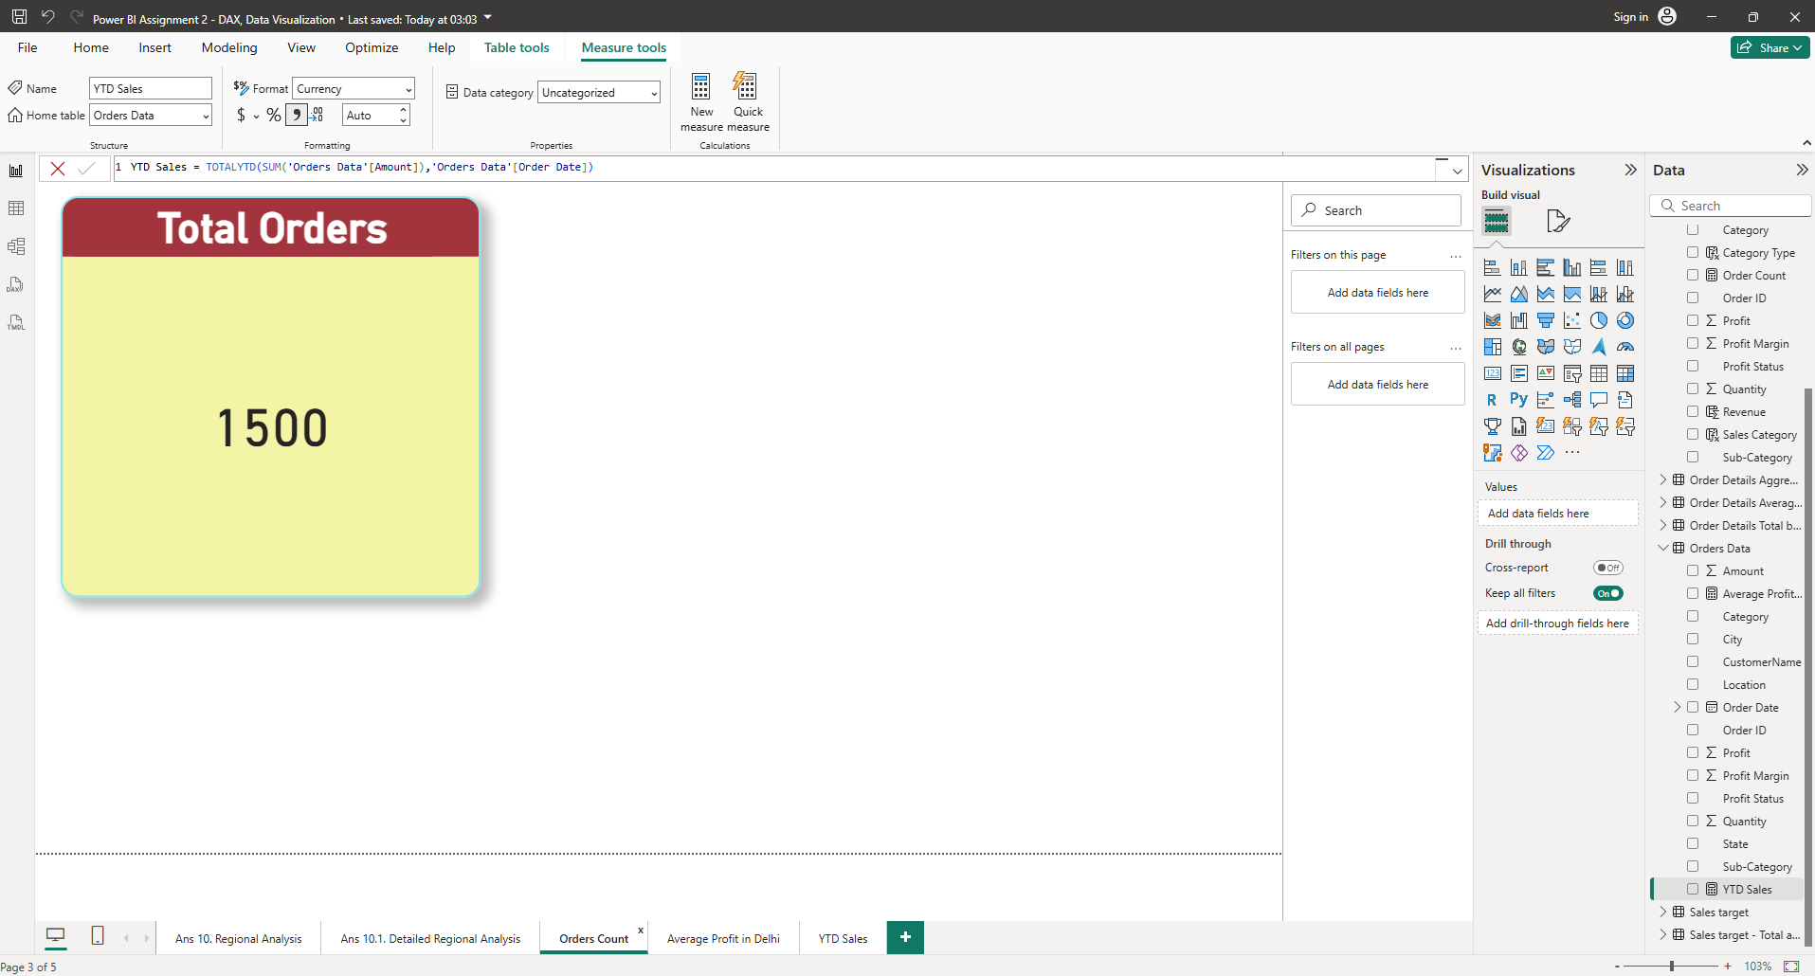  
● **Calculate Average Profit in Delhi**: Create a measure to calculate the average profit for orders placed in Delhi.   
  
**Formula:** Average Profit in Delhi = CALCULATE (AVERAGE ('Orders Data'[Profit]),'Orders Data'[City]="Delhi")

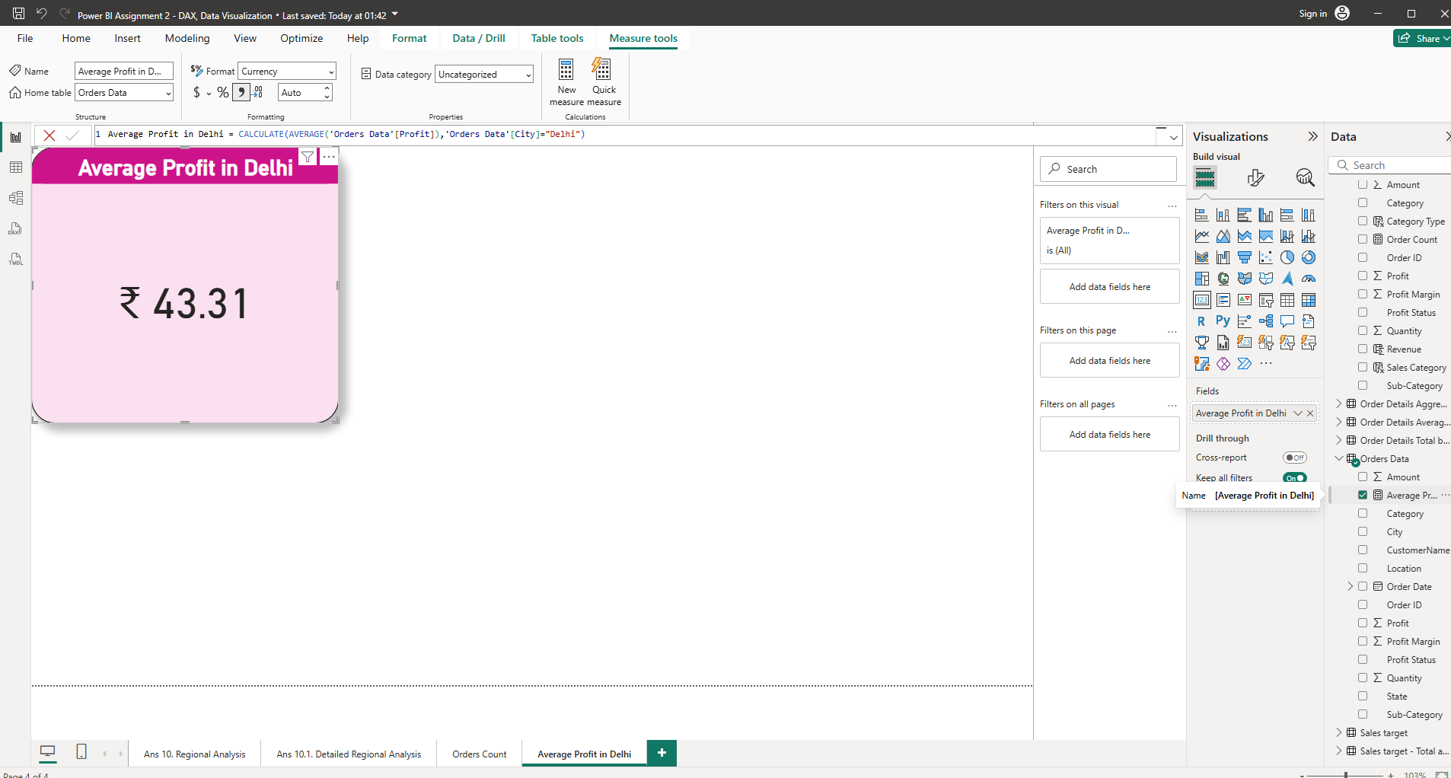  
  
  
● **Calculate Year-to-Date (YTD) Sales**: Define a measure to calculate the total sales amount accumulated from the earliest order date up to each order date.   
**Formula:** **YTD Sales = TOTALYTD (SUM ('Orders Data'[Amount]),'Orders Data'[Order Date])**

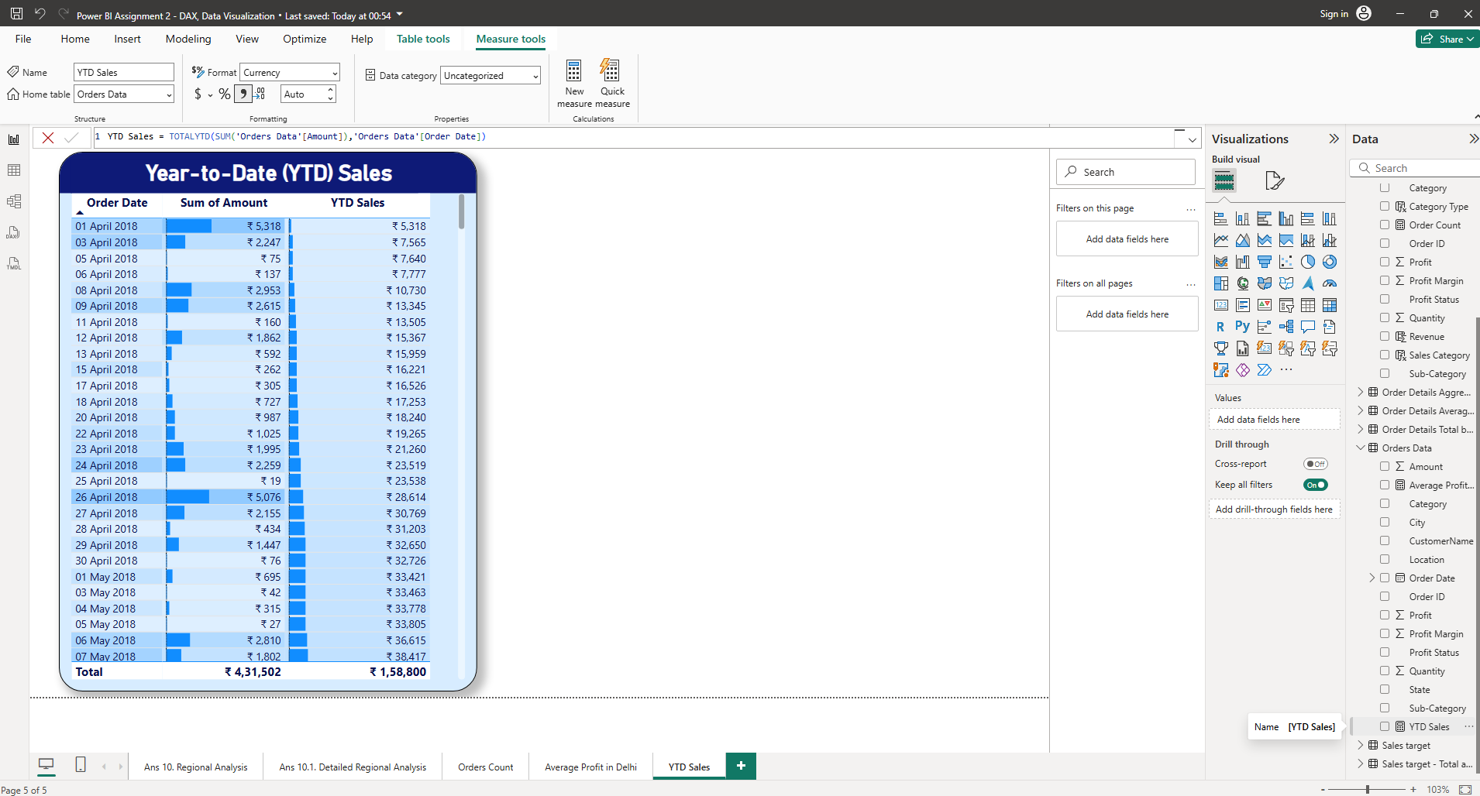**Data Visualization:**

**1. Sales Target Achievement by Category:** Compare actual sales with sales targets by category using a clustered column chart.  
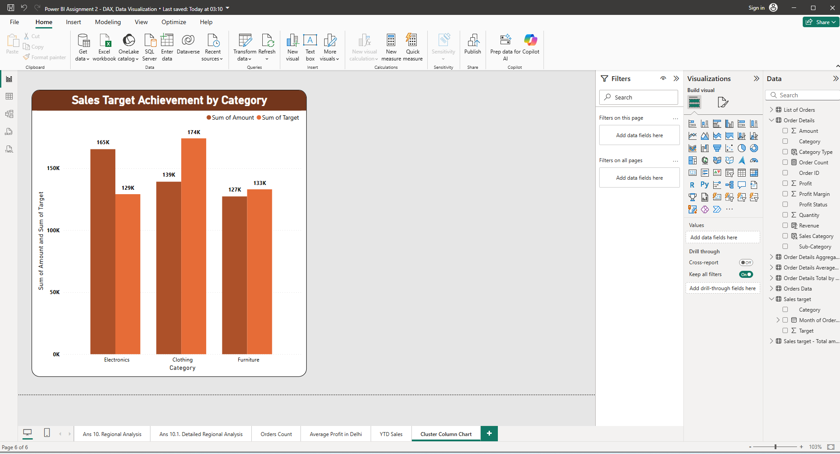  
  
  
  
**2. Max Profit Margin by Sub-Category:** Analyze the maximum profit margin for each sub-category of products using a donut chart.  
**Formula:** **Max Profit Margin = MAX ('Order Details'[Profit Margin])**

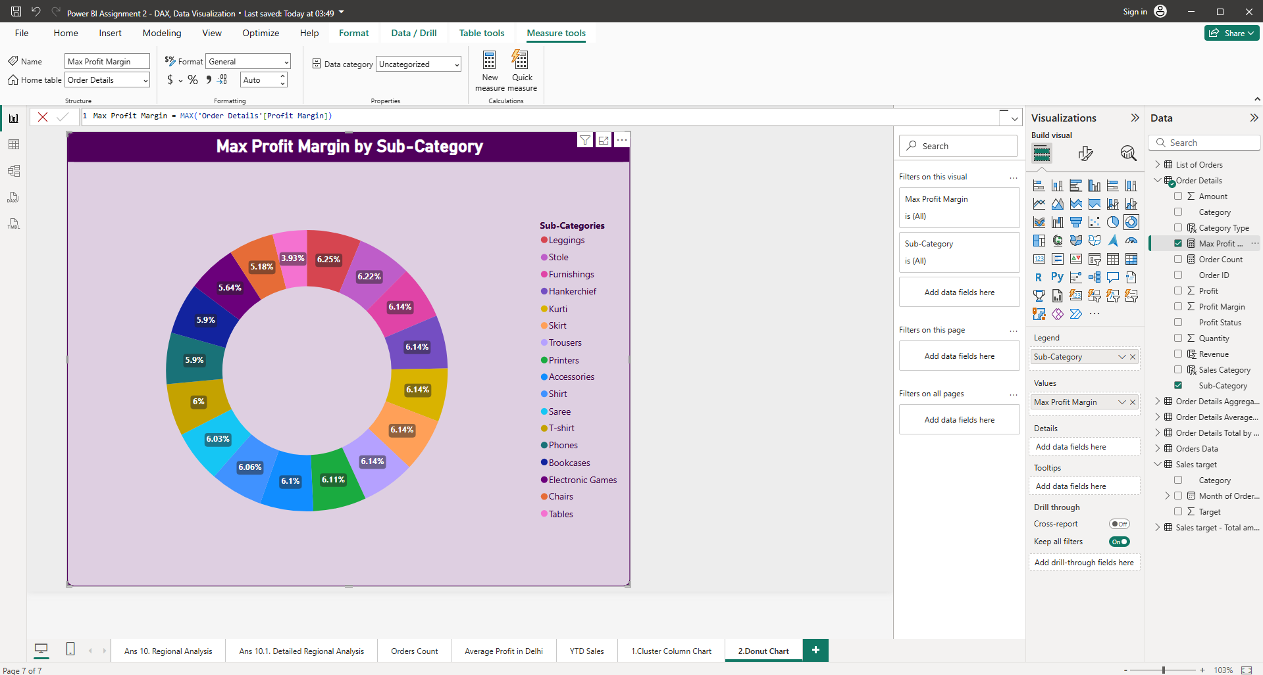  
  
**3. Monthly Sales Trend:** Show the trend of monthly sales over time using a line chart.  
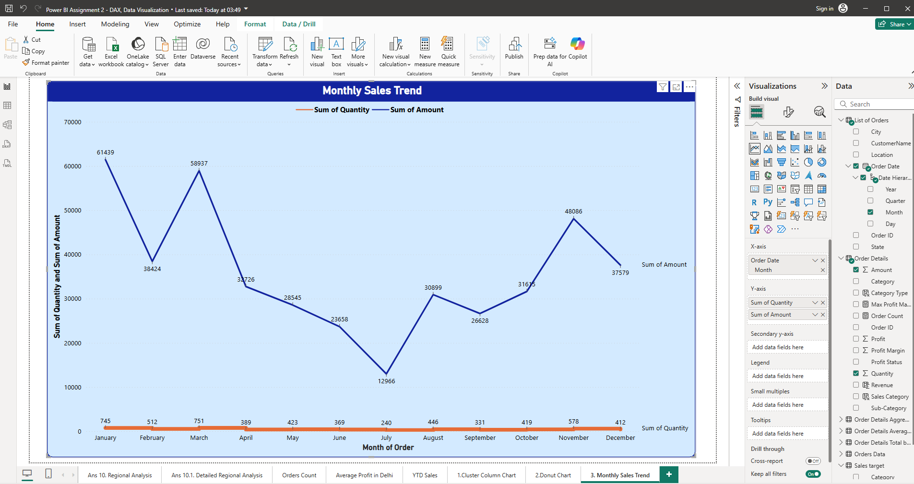  
  
  
  
**4.Comparison of Profit and Quantity by Sub-Category:** Compare the relationship between profit and quantity sold for different sub-categories using a scatter chart.  
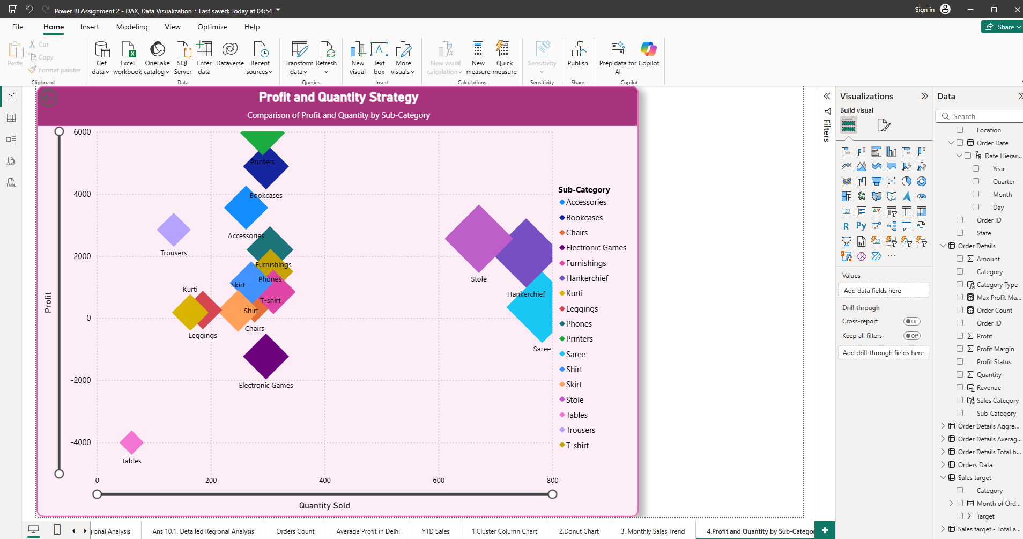  
 **5.Comparison of Total Sales Amount and Target:** Create cards to succinctly display the total sales amount alongside the sales target for quick comparison and analysis. Also, create a multi-row card to display the minimum target for each segment.  
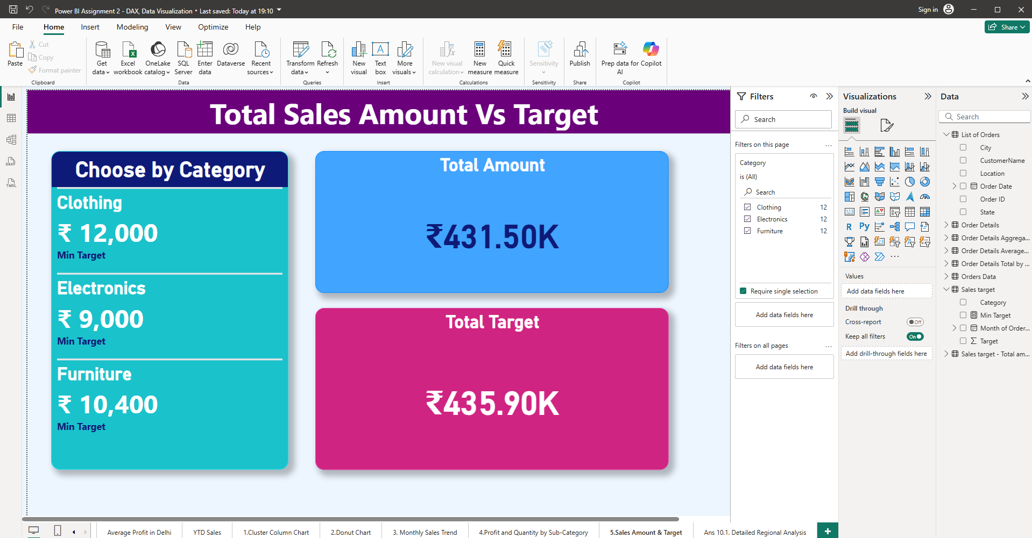  
  
**6.Sales Performance Matrix:** Build a matrix view to analyze how actual sales compare to sales targets across different categories and months.  
  
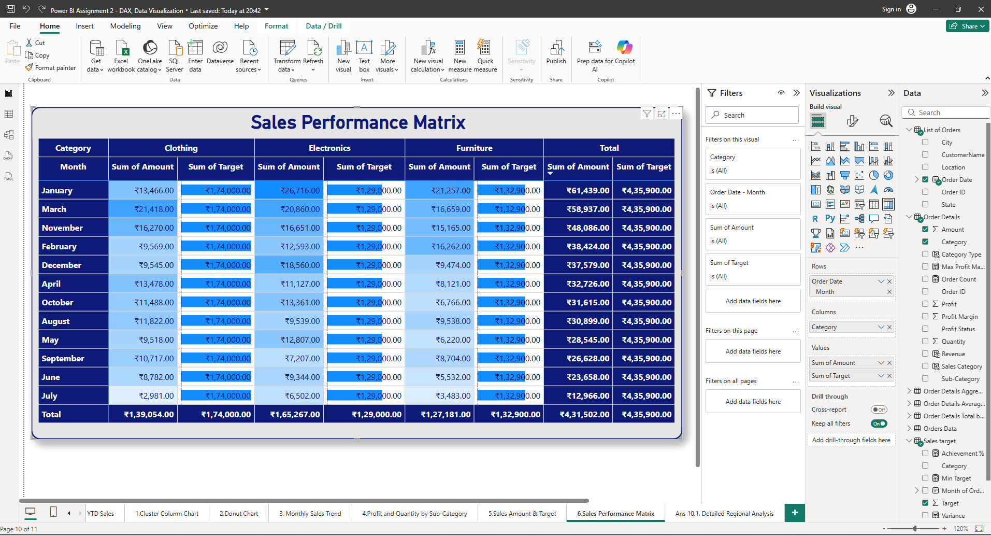

**Summary**

This project successfully demonstrates an end-to-end data analytics workflow covering data transformation, modeling, and visualization. Through the use of Power BI, the analysis delivers clear insights into sales performance, profitability, and regional trends. Key takeaways include improved visibility into sales targets, identification of high-performing categories, and enhanced decision-making through data-driven visual dashboards.

**Conclusion**

The Sales Data Analysis Project provides a practical demonstration of how Power BI and Excel can be used together for efficient business analytics. By integrating clean data models, calculated measures, and insightful visuals, the project enables businesses to monitor key metrics, evaluate performance, and support strategic planning.

* **Thank You -**